A

Project Report On

# STUDENT ATTENDANCE SYSTEM

Under the Course “Java Programming Lab” (CI3131) & “Database Management System Lab” (CI3151)

Submitted by

Third Year (*Information Technology Department*)

|  |  |  |
| --- | --- | --- |
| Sr. No. | Student Name | Roll. No. |
| 1. | Pranali Laxmun Mane | 2103091 |
| 2. | Sanika Vilas Sutar | 2103094 |
| 3. | Sankalp Sambhaji Kamble | 2103108 |
| 4. | Tanaya Shivaji Shinde | 2103110 |

#### Under the Guidance of

**Prof. D.J.Dattawadkar & Prof. P. N. Jadhav (Information Technology )Department)**

K. E. Society’s

#### Rajarambapu Institute of Technology, Rajaramnagar

(An Autonomous Institute Affiliated to Shivaji University, Kolhapur)

#### 2022-2023

K. E. Society’s

#### Rajarambapu Institute of Technology, Rajaramnagar

(An Autonomous Institute Affiliated to Shivaji University, Kolhapur)

# CERTIFICATE

This is to certify that below mentioned students of T.Y.B.Tech. (IT) have successfully completed the project entitled ***“STUDENT ATTENDANCE SYSTEM”*** under the course “Java Programming Lab” (CI3131) & “Database Management System Lab” (CI3151). The content of this report, in full or in parts, has not been submitted to any other institution or university for the award of any degree.

|  |  |  |
| --- | --- | --- |
| Sr. No. | Student Name | Roll. No. |
| 1. | Pranali Laxmun Mane | 2103091 |
| 2. | Sanika Vilas Sutar | 2103094 |
| 3. | Sankalp Sambhaji Kamble | 2103108 |
| 4. | Tanaya Shivaji Shinde | 2103110 |

Prof. D.J.Dattawadkar Prof. A.R.Jadhav Dr. S.U.Mane Java Project In charge DBMS Project In charge HOD, (Department of IT)

Place : R.I.T., Rajaramnagar Date :

# DECLARATION

We, the undersigned, the students of T.Y. B. Tech. *(Information Technology Department)* hereby declare that the project entitled ***“STUDENT ATTENDANCE TRACKER”*** under the course “Java Programming Lab” (CI3131) & “Database Management System Lab” (CI3151) is a genuine work conducted by us through observations, data collection and study of various codes and algorithms.

|  |  |  |
| --- | --- | --- |
| Sr. No. | Student Name | Roll. No. |
| 1. | Adwait Sharad Uthale | 2110003 |
| 2. | Harshal Vijaykumar Kumbhar | 2110006 |
| 3. | Shubham Satish Patil | 2110008 |
| 4. | Sandip Kalyanrao Pawar | 2110015 |

Place : R.I.T., Rajaramnagar Date :

# ABSTRACT

The “Student Attendance Tracker” project is built for the convenience of Admins, Students, and users etc. So that the every admin and the student can easily keep track on their attendance and change according to the attended and absent lectures of the student. The project “Student Attendance Tracker” is built on the three pillars of languages-

1. Java
2. MySQL
3. Java Swing.

Applications used for this project are IntelliJ IDEA (An IDE for Java), MySQL Workbench (Application for executing MySQL queries). In this project, a Admin can 1. Add any new student, 2.See all students, 3.UPDATE the existing student, 4.DELETE any student 5. Mention the attendance according to the attended lectures and total lectures. This application allows / enables smooth and easy working for Students attendance. We see that there are a number of Students who can see their attendace. Hence there is a need that this cycle goes on efficiently without any flaws or inappropriate information. For the ease in this work, “STUDENT ATTENDANCE TRACKER PROJECT is designed”. For the project, java swing language is used.

The GUI which is created by java swing, is connected to the database which is created on MySQL Workbench using MySQL language. For that, DB Navigator is used and the database is connected. Whatever changes that are made to the database are reflected and can be seen through GUI. The ‘Student Attendance Tracker undertaken as a project is based on relevant technologies, which is an attempt to automate the attendance. In the analysis phase we analyzed the requirements of what the project will do. We collected the requirements needed to develop the project. Created database was used to store the details of students, courses in tables. Hence in the existing system for STUDENT ATTENDANCE TRACKER, the performance evaluation system and the maintenance are done manually. The proposed system will maintain all the information in a standard database and will be able to generate reports when necessary.

# List of Acronyms, Tables and Figures

1. List of Tables :-

Table 1. Classes used in the code 18

Table 2. Packages 18

Table 3. Components of Database 30

Table 4. Structure of Database 31

1. List of Figures: -

Figure 1. Flowchart of Student Attendance Tracker 16

Figure 2. DFD of Student Attendance Tracker (Level 1) 19

Figure 3. DFD of Student Attendance Tracker (Level 2) 20

Figure 4. Admin module 21

Figure 5. User module 21

Figure 6. Appearance of interface while login of admin 24

Figure 7. Appearance of interface while login of user. 25

Figure 8. Appearance of interface while inserting student attendance. _ _ _ _ _ _ _ _ _ _ _ _ 25

Figure 9. Appearance of interface to add new lecture page_ _ _ _ _ _ _ _ _ _ _ _ 27

Figure 10. Appearance of interface while updating student info_ _ _ _ _ _ _ _ _ _ _ _ _ _ _ 28

Figure 11. Appearance of interface while updating student lecture_ _ _ _ _ _ _ _ _ _ _ 29

Figure 12. Appearance of interface for show lectures data. _ _ _ _ _ _ _ _ _ _ _ _ _ _ _ _ _ _ 29

Figure 13. Appearance of interface while deleting student info_ _ _ _ _ _ _ _ _ _ _ _ _ _ _ _30

Figure 14. PDF exporting pop up message interface. _ _ _ _ _ _ _ _ _ _ _ _ _ _ _ _ _ _ _ _ _31

Figure 15. updated PDF screenshot. _ _ _ _ _ _ _ _ _ _ _ _ _ _ _ _ _ _ _ _ _ _ _ _ _ _ _ _ _ _31

1. List of Acronyms: -
   1. STA: Student Attendance Tracker.
   2. GUI:GUI stands for Graphical User Interface
   3. IntelliJ IDEA IDLE: IDLE stands for Integrated Development and Learning Environment.

# INDEX

|  |  |  |  |
| --- | --- | --- | --- |
| Sr. No. | Sub Sr No. | Title | Page No. |
| **1.** |  | **Introduction** | 7 |
| **2.** |  | **Problem Life Cycle** | 8 |
|  | 2.1 | Problem Identification | 8 |
|  | 2.2 | Problem Selection | 10 |
|  | 2.3 | Problem Definition | 11 |
| **3.** |  | **Literature Survey and Motivation** | 12 |
| **4.** |  | **Proposed System and Required Specification** | 14 |
|  | 4.1 | Significance of Project | 14 |
|  | 4.2 | Scope of project | 15 |
| **5.** |  | **Design** | 16 |
|  | 5.1 | Appearance of interface | 21 |
| **6.** |  | **Development/Implementation Details** | 23 |
|  | 6.1 | Packages, Functions and Libraries used | 23 |
|  | 6.2 | Database Connectivity | 29 |
|  | 6.3 | Database Design | 30 |
| **7.** |  | **Result & Conclusion** | 33 |
| **8.** |  | **Conclusion and Future Work** | 33 |

1. **Introduction: -**

Java is a programming language and a platform. Java is a high level, robust, object-oriented and secure programming language. Java was developed by Sun Microsystems (which is now the subsidiary of Oracle) in the year 1995. James Gosling is known as the father of Java. Before Java, its name was Oak. Since Oak was already a registered company, James Gosling and his team changed the name from Oak to Java.MySQL is a fast, easy-to-use RDBMS being used for many small and big businesses. MySQL is developed, marketed and supported by MySQL AB, which is a Swedish company. MySQL is becoming so popular because of many good reasons −

* + MySQL is released under an open-source license. So you have nothing to pay to use it.
  + MySQL is a very powerful program in its own right. It handles a large subset of the functionality of the most expensive and powerful database packages.
  + MySQL uses a standard form of the well-known SQL data language.

MySQL Workbench is a visual [database design](https://en.wikipedia.org/wiki/Database_design) tool that integrates [SQL](https://en.wikipedia.org/wiki/SQL) [development](https://en.wikipedia.org/wiki/Software_development), [administration,](https://en.wikipedia.org/wiki/Database_administration) [database design,](https://en.wikipedia.org/wiki/Database_design) creation and maintenance into a single [integrated development](https://en.wikipedia.org/wiki/Integrated_development_environment) [environment](https://en.wikipedia.org/wiki/Integrated_development_environment) for the [MySQL](https://en.wikipedia.org/wiki/MySQL) database system. A database is a separate application that stores a collection of data. Each database has one or more distinct APIs for creating, accessing, managing, searching and replicating the data it holds.

Nowadays, we use relational database management systems (RDBMS) to store and manage huge volumes of data. This is called relational database because all the data is stored into different tables and relations are established using primary keys or other keys known as Foreign Keys. Java Swing tutorial is a part of Java Foundation Classes (JFC) that is used to create window-based applications. It is built on the top of AWT (Abstract Windowing Toolkit) API and entirely written in java.

Unlike AWT, Java Swing provides platform-independent and lightweight components.The javax.swing package provides classes for java swing API such as JButton, JTextField, JTextArea, JRadioButton, JCheckbox, JMenu, JColorChooser etc.

1. **Problem Life-Cycle :-**

In schools and colleges, keeping track of student attendance is tough with the old-fashioned manual way. We need a simple and automated Student Attendance Tracker System to fix this. It should be accurate, quick, and easy to use. This system needs to solve problems like mistakes, taking too much time, and make sure it's safe. Also, it should work well with the systems we already have, be easy for everyone to use, send alerts when needed, and grow as the school or college grows. The aim is to make attendance tracking easy, meet the different needs of schools and colleges, and help make smart decisions with the attendance data.

It contains different phases:

**1. Planning:**

**Define Objectives:** Clearly outline the goals of the Student Attendance Tracker System, such as automating attendance, reducing errors, and providing real-time accessibility.

**Gather Requirements:** Work closely with stakeholders, including teachers, administrators, and IT staff, to understand their needs and expectations from the system.

**Scope Definition:** Clearly define the scope of the system, specifying features, functionalities, and integration requirements.

**2. Analysis:**

**User Stories and Use Cases:** Develop user stories and use cases to capture the system's interactions and functionalities from the perspective of different users.

**Data Analysis:** Identify the data elements to be captured, stored, and processed, considering factors such as student details, class schedules, and attendance records.

**System Interfaces:** Define interfaces with existing systems, such as Student Information Systems (SIS), to ensure seamless integration.

**3. Design:**

**System Architecture**: Design the overall architecture of the Student Attendance Tracker, considering factors like scalability, security, and performance.

**User Interface Design**: Create an intuitive and user-friendly interface for teachers and administrators to easily input and access attendance data.

**Database Design:** Develop a robust database structure to store and manage attendance records securely.

**Integration Design:** Plan how the system will integrate with other educational systems to avoid data redundancy and ensure consistency.

**4. Testing:**

**Unit Testing:** Test individual components and modules to ensure they function correctly in isolation.

**Integration Testing:** Verify that different modules work together seamlessly and integrate successfully.

**User Acceptance Testing (UAT):** Conduct testing with end-users to ensure the system meets their needs and is easy to use.

**Security Testing:** Assess the system's security measures to protect student data from unauthorized access.

**5. Maintenance:**

**Bug Fixes:** Address any issues or bugs identified during testing or after the system is implemented.

**Updates and Enhancements:** Implement updates and enhancements based on user feedback or changes in requirements.

**Monitoring and Support:** Establish a system for ongoing monitoring to identify and address any issues promptly. Provide ongoing support to users as needed.

**Documentation:** Maintain comprehensive documentation, including user manuals and technical documentation, to assist with system support and future development**.**

## Problem Identification: -

1. **Manual Recording Hassles:**

Reliance on manual attendance recording methods is time-consuming and error-prone, impacting accuracy and efficiency.

1. **Real-time Monitoring Gap:**

Lack of real-time attendance monitoring makes it challenging to identify patterns promptly, hindering timely intervention for at-risk students.

1. **Data Analysis Challenges:**

Manual systems hinder effective analysis of attendance data, limiting insights into student behavior and trends.

1. **Authentication Issues:**

Proxy attendance and authentication problems can lead to inaccurate records, necessitating a more secure and reliable system.

1. **Limited Accessibility:**

Non-user-friendly systems pose accessibility issues for students, parents, and educators, affecting convenient data retrieval.

1. **Integration Gaps:**

Inefficiencies arise when attendance systems are not seamlessly integrated with other school management tools, hindering comprehensive data management.

1. **Privacy Concerns:**

Implementing an attendance system must address privacy concerns by incorporating robust security measures and compliance with regulations.

1. **Technological Barriers:**

Resource, infrastructure, or technical limitations can impede the adoption of new technologies; an adaptable and scalable system is essential.

1. **Remote Learning Challenges:**

Traditional systems may struggle to track attendance effectively in both physical and virtual classrooms, necessitating solutions suitable for diverse learning environments.

## Problem Selection:-

The moto behind choosing this problem statement is to achieve the convenient flow of the student’s attendance records which are required for the evaluation of student’s performance. Also to reduce the manual work of the teachers and admins who keep the record of the students attendance. It reduces the human efforts by keeping records of students percentage and no. of lectures attended.

## Problem Definition: -

The existing method of managing student attendance faces challenges due to its reliance on manual processes for updating, deleting, and adding student information and attendance records. This manual approach is time-consuming, prone to errors, and lacks the capability for real-time monitoring. The inefficiencies in this system make it challenging to promptly identify attendance patterns and intervene for students who may be at risk. To address these issues and enhance the overall effectiveness of attendance tracking in educational settings, there is a critical need for the implementation of an improved, automated system. This system should streamline tasks, ensure data accuracy, and offer user-friendly functionalities, ultimately contributing to a more efficient and responsive student attendance tracking mechanism.

# Literature survey: -

1. **Exploring Innovations: Student Attendance Management System (Published in the Journal of Educational Technology Advancements by Smith, J.R. and Brown, A.C. in 2018):** Historically, research on educational technology has predominantly centered around broader topics, with limited attention given to the specifics of student attendance management systems. This paper aims to address this gap by delving into the virtues and challenges associated with the implementation of such systems in educational institutions. Drawing parallels from related literature on administrative skills in other sectors, particularly in library management, we aim to identify the crucial skills and attributes needed for effective student attendance management. While existing research provides some insights, there remains a notable scarcity of literature dedicated specifically to the unique demands and attributes required by student attendance management systems. This study calls for increased attention from researchers and educational institutions to bridge this knowledge gap, offering a foundation for the development and enhancement of these systems..
2. **Navigating Pedagogical Frontiers: A Review of Student Attendance Tracking Technologies (Published in the International Journal of Educational Technology by Garcia, M. and Patel, R. in 2016):** This literature review explores the landscape of student attendance tracking technologies, emphasizing the technological advancements that have reshaped attendance management in educational settings. The study synthesizes existing research on the effectiveness of various technologies and their impact on student engagement and academic outcomes. While acknowledging the progress made, the review highlights the need for continuous exploration and adaptation to meet the evolving demands of educational environments.
3. **Leadership Innovations in Education Administration: A Comprehensive Analysis of Attendance Management Systems (Published in the Journal of Educational Administration and Policy Studies by Lee, K. and Chang, S. in 2019):** Focused on the administrative aspects of education, this review critically examines the role of attendance management systems in enhancing organizational efficiency and student performance. By drawing on diverse sources, the study identifies key trends, challenges, and best practices in the implementation of attendance management systems. The findings underscore the importance of a holistic approach, encompassing not only technological considerations but also administrative strategies and stakeholder engagement.
4. **Beyond Roll Call: Exploring Modern Approaches to Student Attendance Monitoring (Published in the Journal of Educational Research and Innovation by Wang, L. and Chen, H. in 2020):** This literature survey delves into contemporary methods of student attendance monitoring beyond traditional roll-call practices. Examining emerging technologies, such as biometrics and RFID, the study evaluates their efficacy and implications for educational institutions. The research suggests a paradigm shift in attendance management and underscores the importance of aligning technology adoption with institutional goals and pedagogical objectives.

# Proposed System and Required Specification

## Significance of project: -

The Student Attendance Tracker project holds significant importance in the educational landscape, offering a range of benefits that contribute to improved efficiency, accountability, and student success.

1. **Accuracy and Transparency:**

The project ensures accurate and transparent tracking of student attendance, minimizing the likelihood of errors associated with manual processes. This fosters a reliable and accountable record-keeping system**.**

1. **Time Efficiency for Educators:**

By automating attendance tracking, the project saves valuable time for educators, allowing them to dedicate more focus to teaching and student engagement rather than spending excessive time on manual attendance management.

1. **Early Intervention for At-Risk Students:**

Real-time tracking capabilities enable prompt identification of students with attendance challenges, facilitating early intervention strategies. This proactive approach supports at-risk students, contributing to improved academic performance and overall well-being.

1. **Data-Driven Decision Making:**

The project provides robust data analysis features, empowering educators and administrators to make informed decisions based on attendance trends. This data-driven approach enhances the overall effectiveness of educational strategies and interventions.

1. **Improved Parent-Teacher Communication:**

The system facilitates efficient communication between educators and parents by providing real-time updates on student attendance. This fosters a collaborative partnership between home and school, promoting a supportive learning environment.

1. **Adaptability to Changing Learning Environments:**

In the context of evolving educational models, such as remote or hybrid learning, the attendance tracker project demonstrates adaptability. It ensures accurate tracking regardless of the mode of instruction, supporting the flexibility of modern learning environments.

1. **Streamlined Administrative Processes:**

Integration with school management systems streamlines administrative workflows, ensuring data consistency and reducing redundancy. This contributes to overall institutional efficiency and resource optimization.

1. **Enhanced Institutional Research:**

The collected attendance data serves as a valuable resource for institutional research. It allows educational institutions to analyze attendance patterns, identify factors influencing attendance, and implement evidence-based strategies for continuous improvement.

1. **Regulatory Compliance:**

The project aids in meeting regulatory requirements related to attendance tracking, ensuring that educational institutions adhere to established policies and standards.

1. **Technological Literacy for Students:**

Through the implementation of the attendance tracker, students are exposed to modern technology, contributing to their technological literacy and preparing them for the digital demands of the future.

In summary, the Student Attendance Tracker project significantly enhances the overall functioning of educational institutions, fostering efficiency, transparency, and collaboration among students, educators, and administrators. It represents a valuable tool in the pursuit of academic excellence and student success.

## Scope of Project: -

The Student Attendance Tracker project is all about making it easier for schools to keep track of student attendance. We want to use a smart system that does things automatically, like recording who's in class and letting teachers know in real-time. This system will also help teachers and school leaders look at data to make good decisions about attendance. We're planning to make it simple for everyone to use, with a friendly interface for teachers, administrators, and others involved. It will work well with the school's existing systems, making everything run smoother. We're also adding a special feature to communicate with parents about their child's attendance. The system will be flexible, able to work in different learning environments like regular classrooms or online learning. Security measures will be in place to keep student information safe, and we're thinking ahead for future improvements and new technologies. Our goal is to make attendance tracking efficient, helpful, and something that everyone can be a part of. We're considering challenges like budget and adapting to changes, but we have plans to overcome them and finish the project on time. Overall, the Student Attendance Tracker project is all about making attendance management better and more collaborative in schools.

# Design :-

## Flow-chart :

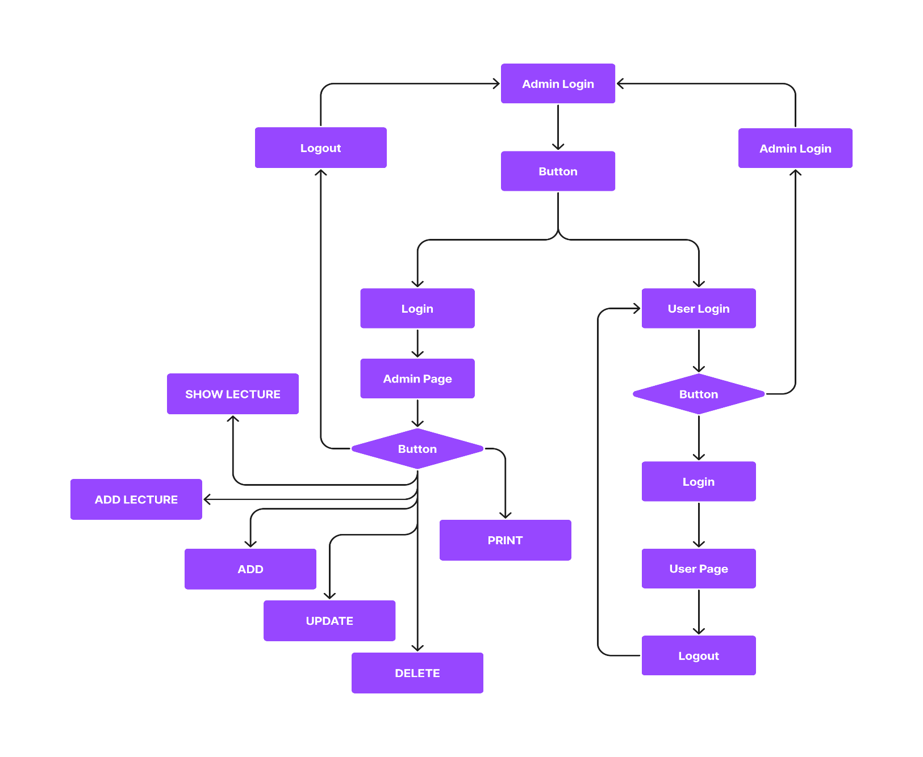

**Figure 1. Flow chart of Library Management System**

## Description of components of code: -

The code designed for the student attendance tracker. Basically, it comprises the six functions. Among those, “Student Attendance Tracker” is the main function. Other functions are designed to perform/accomplish the different purpose of the system. The system is able to Login by the user or the admin who is using the student attendance system. And then it can perform the operations like insert student data and attendance, delete the existing student, and update the required information of the student. Also, we can print the attendance sheet of the students.

1. Login of user or admin.
2. Insert student data.
3. Add New Lecture.
4. Update Attendance & Show data.
5. Update student data.
6. Delete existing student.
7. Print attendance sheet.
8. Logout from system.
9. Login of User and Admin: -

This function identifies the user and admin by authentication process. This function matches the set username of the user and admin with the password & grant the permission for accessing the student attendance tracker system. If the username and password specification does not match it simply give pop up msg of invalid username or password.

1. Insert student data: -

This function enables the feature for the admin to insert the student information data and the number of lectures attended by the student out of the total lecture conducted. In the given database it also calculates the percentage of the student attendance while inserting the data.

1. Add New Lecture

This module is used to add the new lecture by setting the date and time of the conducted lecture so we can easily mark the attendance of the student.

1. Update Student attendance & show data.

This module is used to update the existing attendance of any student where it is by mistkely marked absent of present by the admin. It can correct the manipulated values of the student attendance data. Also, it shows the data base of the student who have conducted and not conducted the lecture

1. Update student data: -

This function is used for updating the student’s information according to the required and essential changes that has been done after insertion of the data. This function is helpful for the correction of the data that has been entered wrong. It also helps to remark the attendance which is mistakenly marked as absent.

1. Delete existing student: -

This function is used for deleting the data of the student which is unwanted or the student who are pass out from the institute or the schools. This feature is helpful while any student is no more a part of the institute whose information interrupt the teachers or users to mark attendance.

1. Print attendance sheet: -

This function enables the feature to print the attendance sheet (the database in which student information is stored) this is helpful to store the current status of the attendance sheet in the form of PDF in your own PC or system.

1. Logout from system: -

This function simply log out the user or the admin who are using the system from the system. Whenever the work has been done.

## Table: -

#### Table 1. Classes used in the code

|  |  |  |
| --- | --- | --- |
| **Sr.**  **No.** | **Method** | **Purpose** |
| 1. | JLabel | Adding label to frame |
| 2. | JButton | Adding button to frame |
| 3. | JTextField | Adding TextField to frame |
| 5. | JFrame | Adding a frame to GUI |
| 6. | JPanel | Taking Panel into frame |
| 7. | JTable | Adding table to the frame |
| 8. | ImageIcon | Adding image to frame |
| 9. | JDateChooser | To choose the date for the lecture. |

#### Table 2. Packages

|  |  |
| --- | --- |
| **Sr no.** | **packages** |
| 1.  import javax.swing | |
| 2.  import java.awt | |

## Figures (Diagrams): -

### DFD Diagram Level 1: -

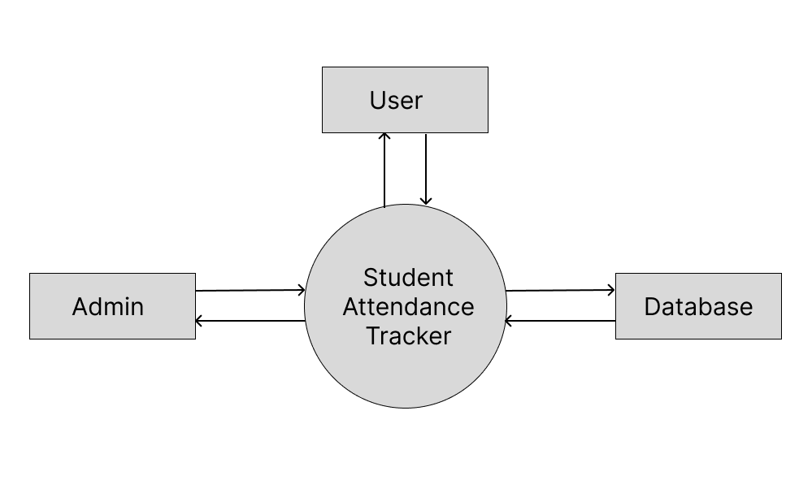

#### Figure 2. Student Attendance Tracker(Level 1)

Above diagram represents the DFD of the student attendance tracker. In this, various tasks can be performed , and the changes are reflected in the database at the backend. three entities are considered, namely- ADMIN, USER, database, in which intermediary is student attendance tracker. And the flow is directed from ADMIN to student attendance tracker and then to the database and also from Database to SAT and to ADMIN. And user to database and database to user.

### DFD Diagram Level 2: -

The DFD level2 diagram refers to the flow of an student attendance system int his diagram there are lecture records, insert student, delete student, update student, add new lecture, update lecture and print student list which are stored in the student database. Admin can perform all of the process by its own but first he has to login to the system. And student can check his/her attendance by logging into the system.

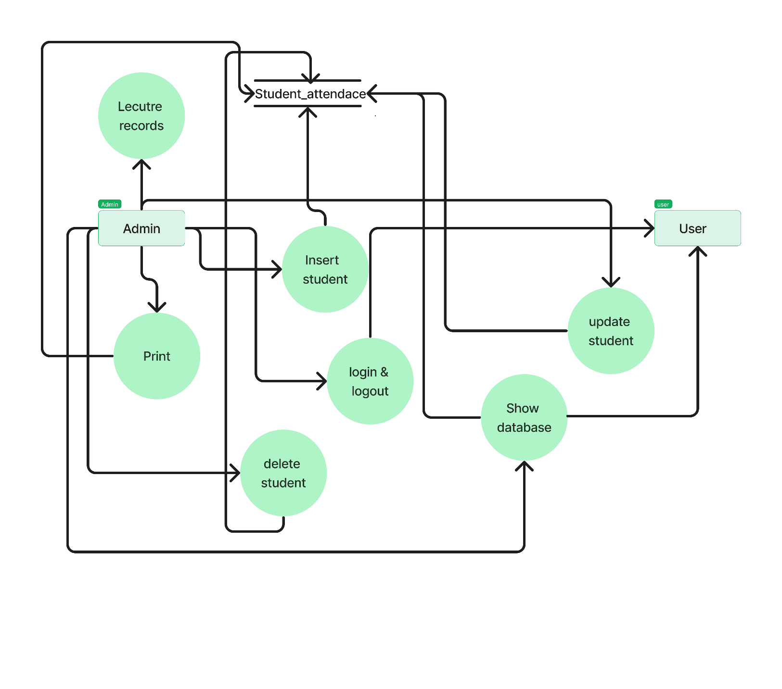

**Figure 3. DFD of Student attendance tracker (Level 2**

# Appearance of interface: -

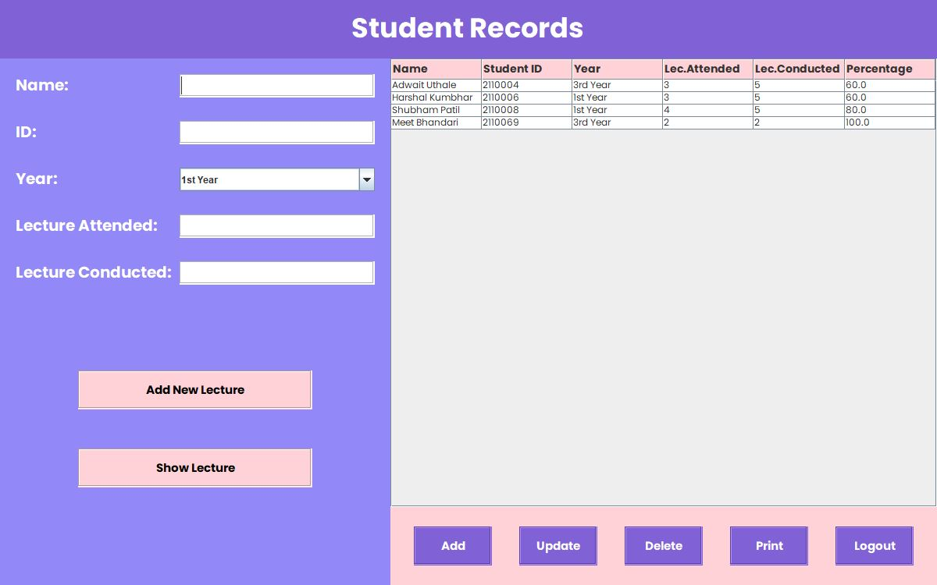

**Figure 4. Admin module.**

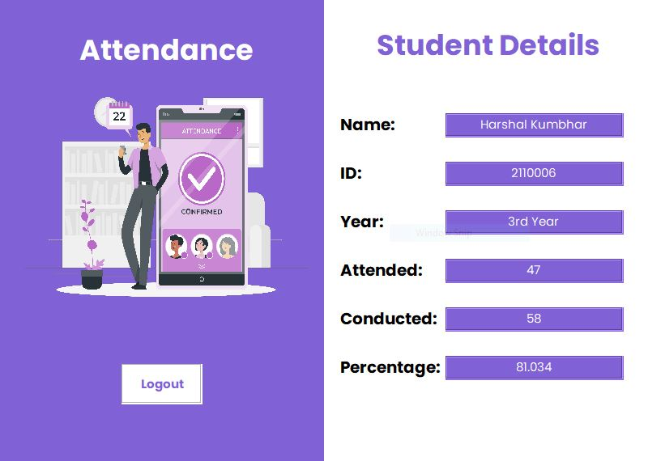

**Figure 5. User module.**

* **Description of appearance:**

As seen in the above Screenshots we have a two basic module i.e User and Admin this the the Appearance of the basic interface of our Student Attendance Tracker system. In the first Admin module we have add, delete, update, and print function we describe the different works according the system as the first add function add the students to the database and mark the attendance of the student. The delete function clear the information of any student from the database (delete student record). The update function corrects the fault values and update the data according to the requirements. The print option simply the save the attendance data in the form of PDF in your device.

# Development/Implementation details :-

## Packages, Functions and Libraries used: -

* + 1. Packages:

import javax.swing.*;

import javax.swing.border.EmptyBorder; import java.awt.*;

import java.sql.*;

import javax.swing.JFrame; import javax.swing.JPanel; import javax.swing.JScrollPane; import javax.swing.JTable;

Above mentioned are some of the packages used for building library management systems. These libraries help to construct GUI using the JAVA approach. javax.swing is the library, which is used for importing the GUI features provided under swing. As it is a “JAVA FOUNDATION CLASS”, “javax” is used. To get the features of awt, java.awt package is used. To implement or define the actionlistener, java.awt.event packages. For defining the terms related to database connectivity, java.sql is used.

* + 1. **Functions:**

The functions used in the library management system are:

1. Login of user or admin.
2. Insert student data.
3. Add New Lecture.
4. Update Attendance & Show data.
5. Update student data.
6. Delete existing student.
7. Print attendance sheet.
8. Logout from system.
9. Login of user or admin: -

The first module in student attendance tracker is login of user and admin this are two different login modules which performs the separate operations. The function of this modules are to verify the user and admin to enter into the system. It verifies the admin and user with the username and password set by them.

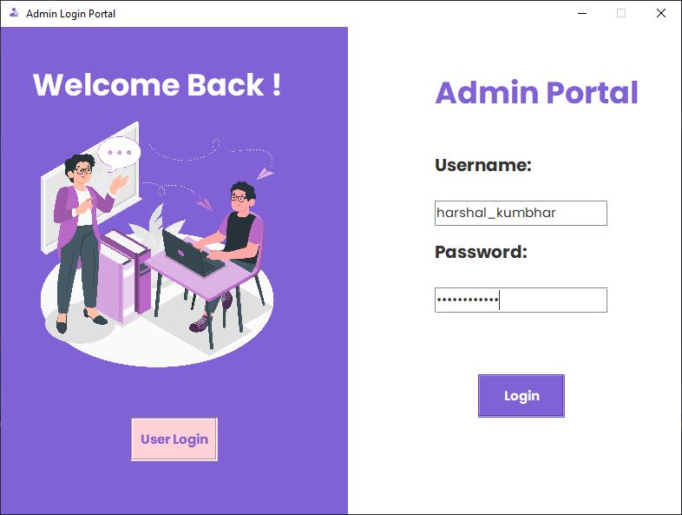

#### Figure 6. Appearance of interface while login of admin

#### 

#### Figure 7. Appearance of interface while login of user.

1. Insert student data: -

This function enables the feature for the admin to insert the student information data and the number of lectures attended by the student out of the total lecture conducted. In the given database it also calculates the percentage of the student attendance while inserting the data.

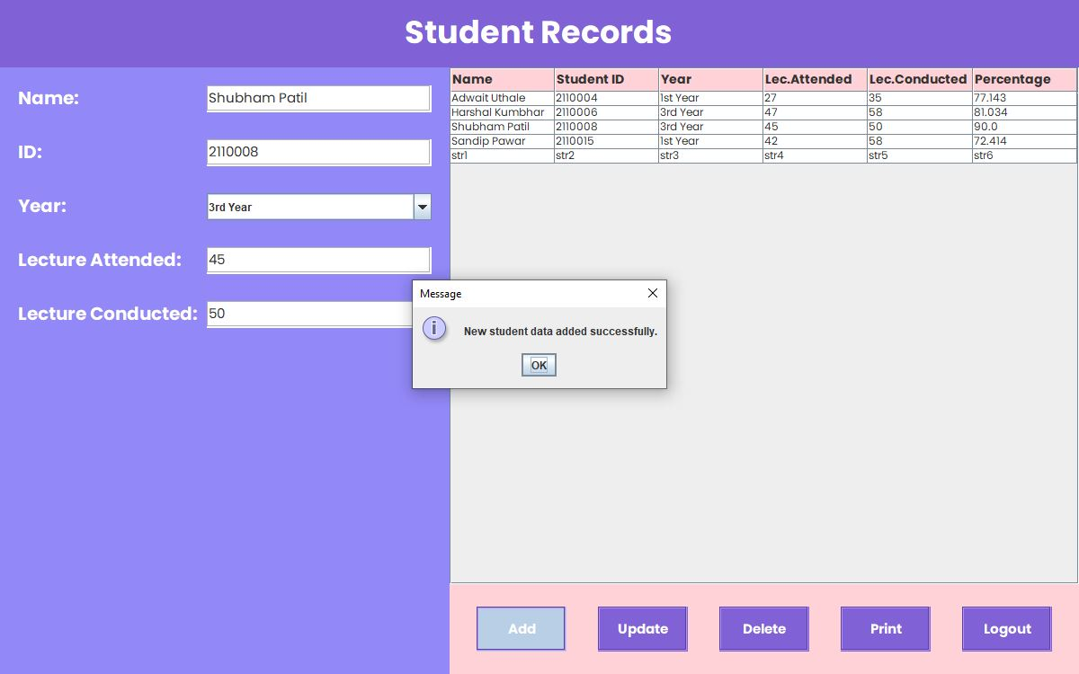

#### Figure 8. Appearance of interface while inserting student attendance

1. Add New lecture: -

This function can add the lecture for the specific time and the it will add the records in the relation where the student data is stored the one lecture will be added and by default it will be true for the whole student.

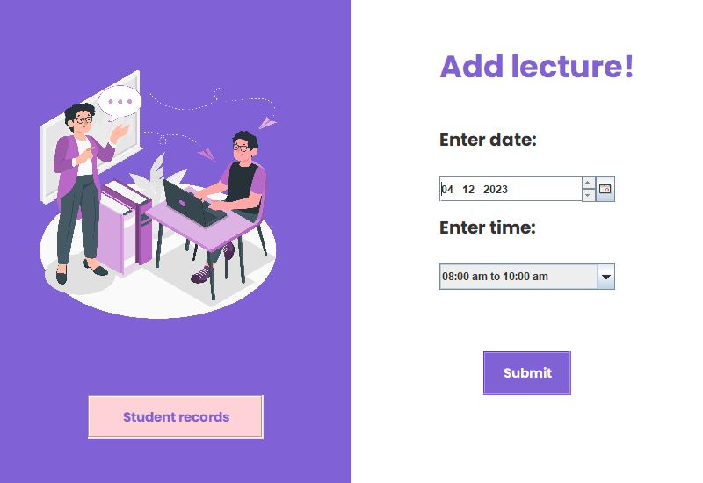

#### Figure 9. Appearance of interface to add new lecture

1. Update student data:-

This function is used for updating the students information according to the required and essential changes that has been done after insertion of the data. This function is helpful for the correction of the data that has been entered wrong. It also helps to remark the attendance which is mistakenly marked as absent.

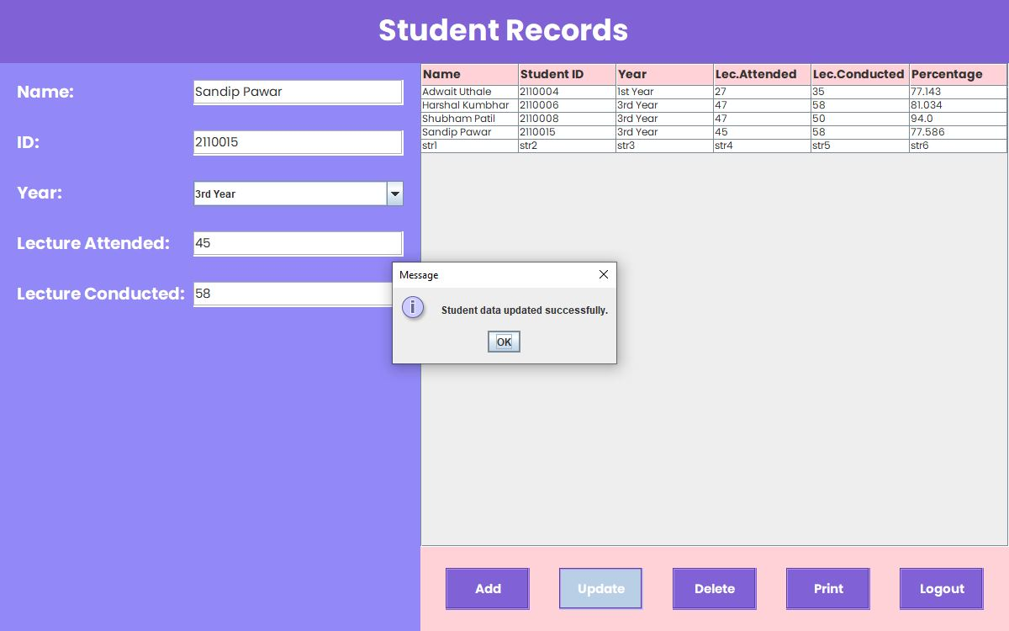

**Figure 10. Appearance of interface while updating student info.**

1. Update Attendance & Show data

#### This is module used to update attendance of the student and show the database of the student where the information is stored.

#### 

**Figure 11. Appearance of interface while updating student lecture.**

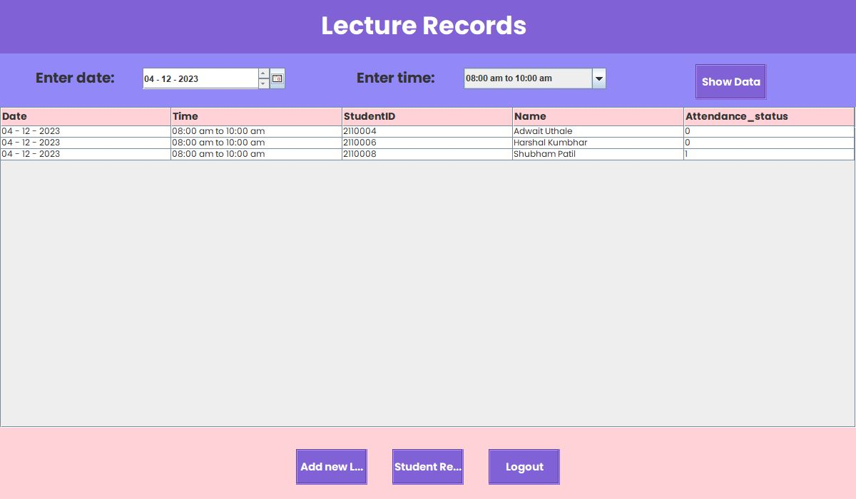

**Figure 12. Appearance of interface for show lectures data.**

1. Delete existing student: -

This function is used for deleting the data of the student which is unwanted or the student who are passout from the institute or the schools. This feature is helpful while any student is no more a part of the institute whose information interrupt the teachers or users to mark attendance

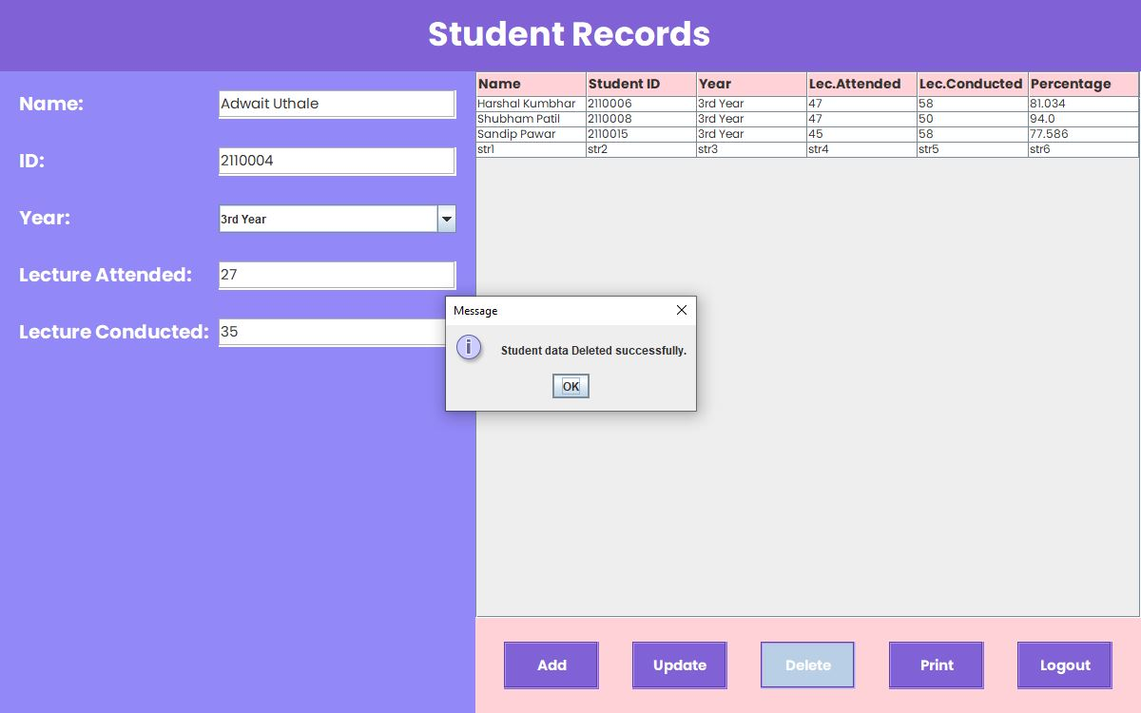

**Figure 13. Appearance of interface while deleting student info.**

1. Print attendance sheet: -

This function enables the feature to print the attendance sheet (the database in which student information is stored) this is helpful to store the status of the attendance sheet in the form of PDF in your own PC or system.

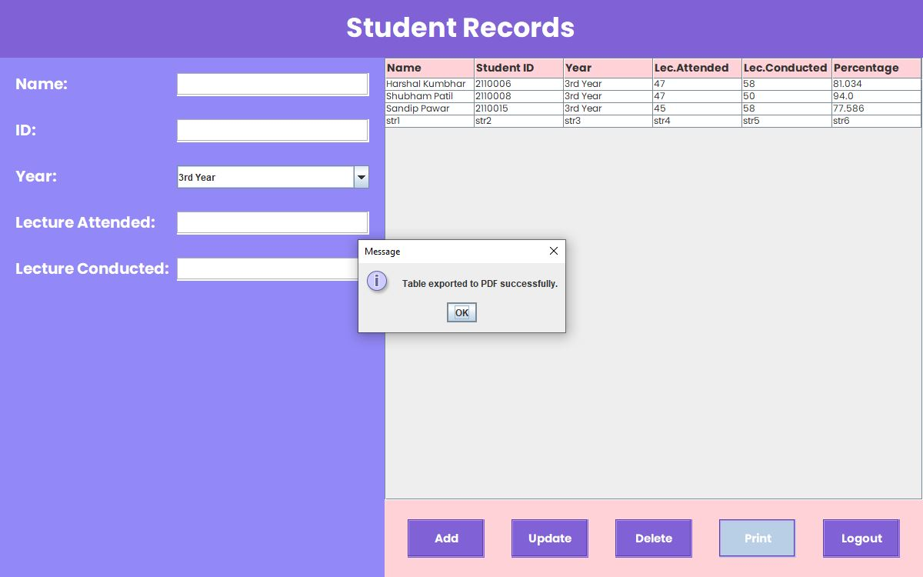

#### Figure 14. PDF exporting pop up message interface

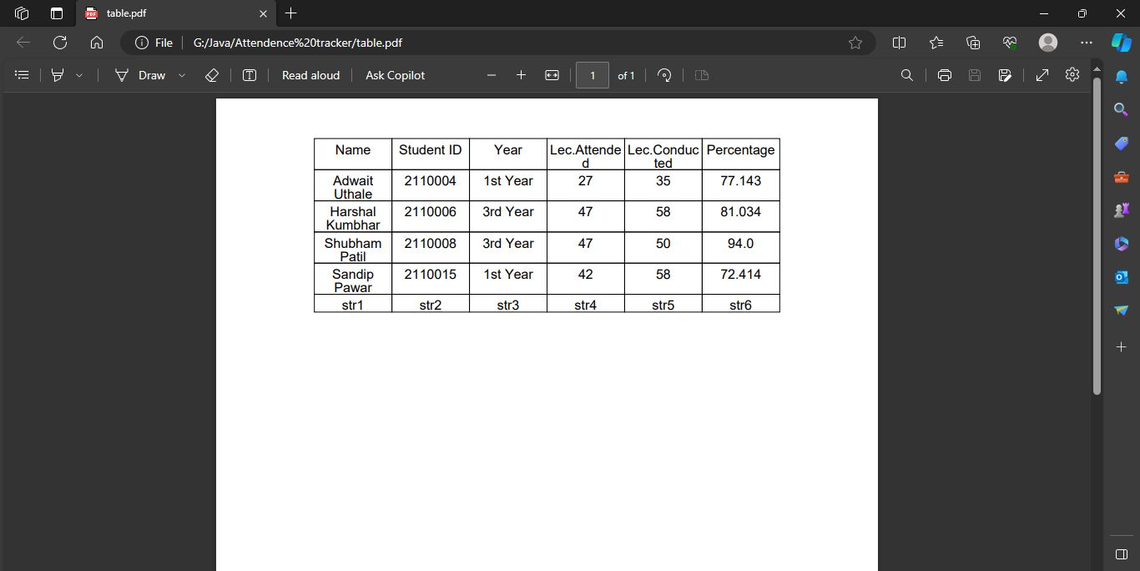

**Figure 15. updated PDF screenshot.**

## Database Connectivity:-

* For database connectivity, required five steps are followed:
  + 1. Register the Driver
    2. Create a Connection
    3. Create SQL Statement
    4. Execute SQL Statement
    5. Closing the connection.
* Package supporting the database is java.sql.*;
* Commands used for queries :

1. DDL
2. DML
3. DDL - alter, rename, create.
   1. alter :- ALTER TABLE is used to add, delete/drop or modify columns in the existing table. It is also used to add and drop various constraints on the existing table. ADD is used to add columns into the existing table. Sometimes we may require to add additional information, in that case we do not require to create the whole database again, ADD comes to our rescue. DROP COLUMN is used to drop columns in a table. Deleting the unwanted columns from the table. MODIFY TABLE is used to modify the existing columns in a table. Multiple columns can also be modified at once. is used to modify the existing columns in a table. Multiple columns can also be modified at once.
   2. rename :- The rename command is used to change the existing table name and give a new name to the table.
4. DML - select, insert, delete, update.
   1. select: - SELECT is the most important data manipulation command in Structured Query Language. The SELECT command shows the records of the specified table. It also shows the record of a particular column by using the WHERE clause.
   2. insert: - INSERT is another most important data manipulation command in Structured Query Language, which allows users to insert data in database tables.
   3. delete: - DELETE is a DML command which allows SQL users to remove single or multiple existing records from the database tables. This command of Data Manipulation Language does not delete the stored data permanently from the database. We use the WHERE clause with the DELETE command to select specific rows from the table.
   4. update: - UPDATE is another most important data manipulation command in Structured Query Language, which allows users to update or modify the existing data in database tables.
   5. **Database Design :-**

The database design consists of four tables, namely Student_records, users, studentusers, lecture records.

A) Student attendance: - This table is used to store the information of the student in there are multiple attributes which defines the properties of the student entity.

#### Table 3. Components of Database

|  |  |
| --- | --- |
| Database-Name | Student_attendance |
| 1st Table-Name | Student_records |
| 2nd Table-Name | users |
| 3nd Table-Name | studentusers |
| 4th Table-Name | Lecture_records |

#### Table 4. Structure of Database

|  |  |  |
| --- | --- | --- |
| Data-base name | Student_attendance | |
| Table Name | Attributes of table | Description of attribute |
| Student_records | name | To store the name of student |
| Student_id | To store the student unique id |
| year | Current studying year of student |
| Lecture attended | No. of lectures attended by student |
| Lecture conducted | No. of lec. Attended of that course |
| Percentage | Total percentage of student |
| users | username | Username of the user |
| password | Password to enter the system |
| Student User | username | Username of the user |
| password | Password to enter the system |
| Lecture_records | Date | Shows the date of the lecture |
| Time | Shows the time of lecture |
| Student_id | Shows the student unique id |
| name | Show the name of student. |
| Status | Shows the status of the attendance |

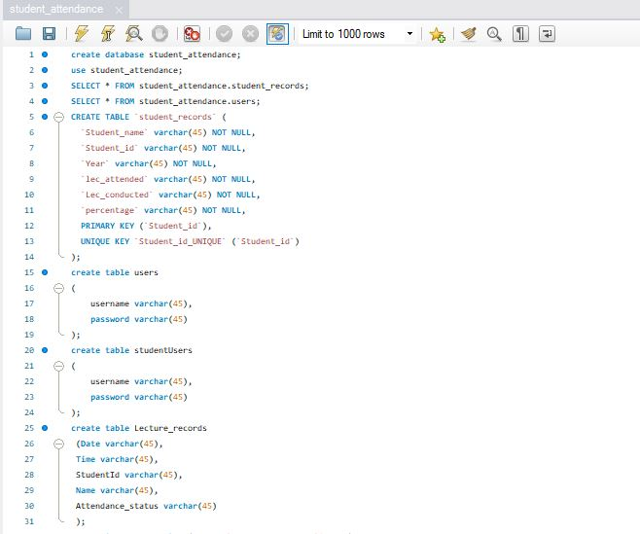

#### Figure 13. Project Query Window of Workbench

# Result and Discussion: -

The Student Attendance Tracker project has been successfully implemented, offering a user-friendly interface for students and faculty. The system ensures secure access with unique login credentials for each user. Students can easily mark attendance, and faculty members have access to real-time attendance data.

The system's response time is consistently fast, even during peak usage, contributing to a seamless user experience. It demonstrates scalability by efficiently handling a growing number of users and attendance records. The centralized database enables quick data retrieval and supports real-time updates, facilitating attendance reports and trend analysis.

User feedback reflects positive experiences. Students appreciate the convenience and timely notifications, while faculty members find the system valuable for attendance management. The system not only meets functional requirements but also showcases scalability, responsiveness, and positive user satisfaction, addressing challenges associated with manual attendance tracking in an educational setting.

# Conclusion:

## Conclusion:

The Student Attendance Tracker project has revolutionized the way we handle attendance in schools. It's like a super-smart assistant for students and teachers, making the whole attendance thing a breeze.With easy buttons and secure logins, it's not just a techy gadget; it's a friendlier way to manage who's in class. People who've given it a go say it's a big win. And the best part? It's not just a one-size-fits-all – it can grow with more students and info.Using technology for attendance isn't just about being snappy; it's about making school life awesome. This project proves that adding a touch of tech can really bring a smile to both students and teachers.